Instructions on how to apply for a position at a local health department (LHD).

April 5, 2021

Purchase District Health Department

Adapted from LHDCOS UserGuide V2

INTRODUCTION
LHDCOS is an application for people seeking employment at the Local Health Departments in the Commonwealth of Kentucky. It is also a portal for job postings and candidate selection by LHD and AFM users. There are three roles in the system: Citizen, LHDUser, and AFMUser.

KENTUCKY ONLINE GATEWAY(KOG)
The Kentucky Online Gateway(KOG) is the sign-on portal. Each user will need to have a KOG account. A first time user will be directed to create an account. The first screen is below. You will choose from the options as follows:
- Citizen or Business Partner- an applicant wanting to create a profile and apply for a Local Health Department (LHD) position
Or
If you are an LHD User and your health department is not on the State network, choose the first option.

- State employee/Contractor within a COT consolidated agency- If you are an LHD User and your health department is on the State network, you will pick the second option.

TO CREATE AN ACCOUNT TO APPLY FOR A POSITION PLEASE SELECT CREATE ACCOUNT.
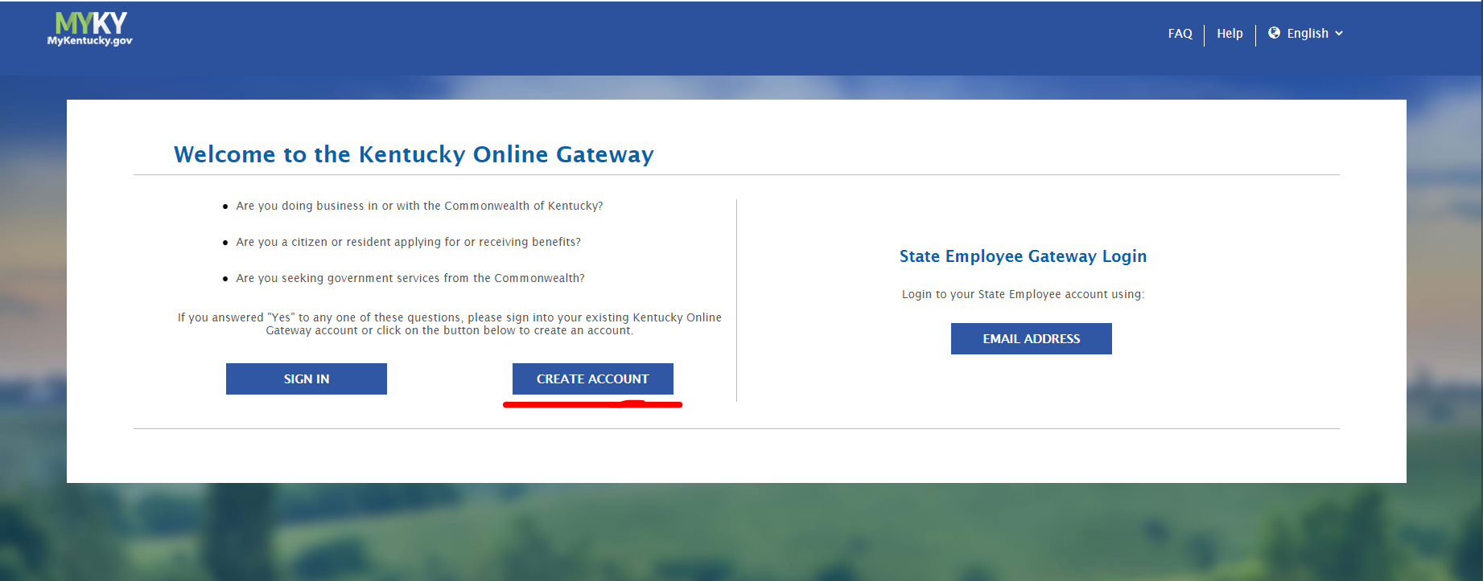

** If you are an LHD employee and want to apply to an open position, you must create a citizen account. You cannot apply using a KOG account that you use for LHD work.

For new users, you will create an account. See the screenshot below.

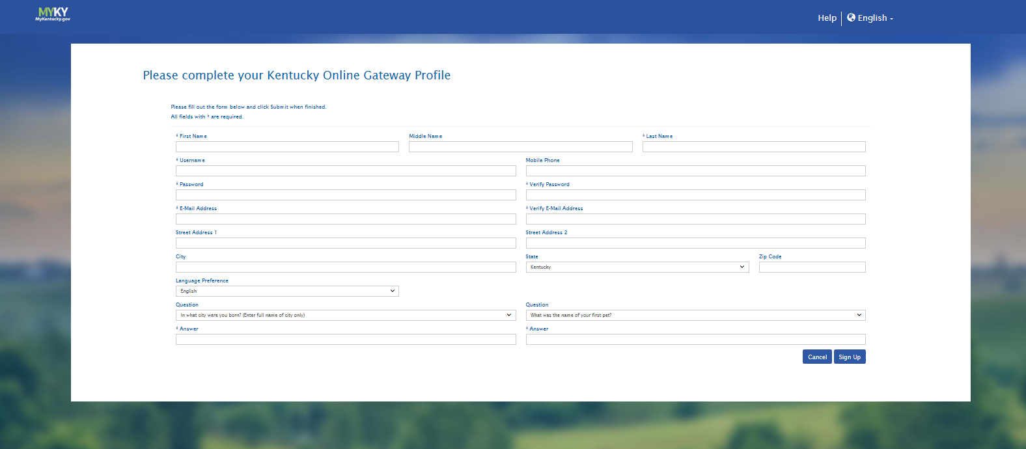

- Once logged into KOG, your dashboard will appear.
- A new user in KOG will see the "All Apps" tab. This dashboard initiates the application request process. Select the "Enroll" button on the appropriate tile.
- Select the LHDCOS Search and Apply tile to request Citizen Role.

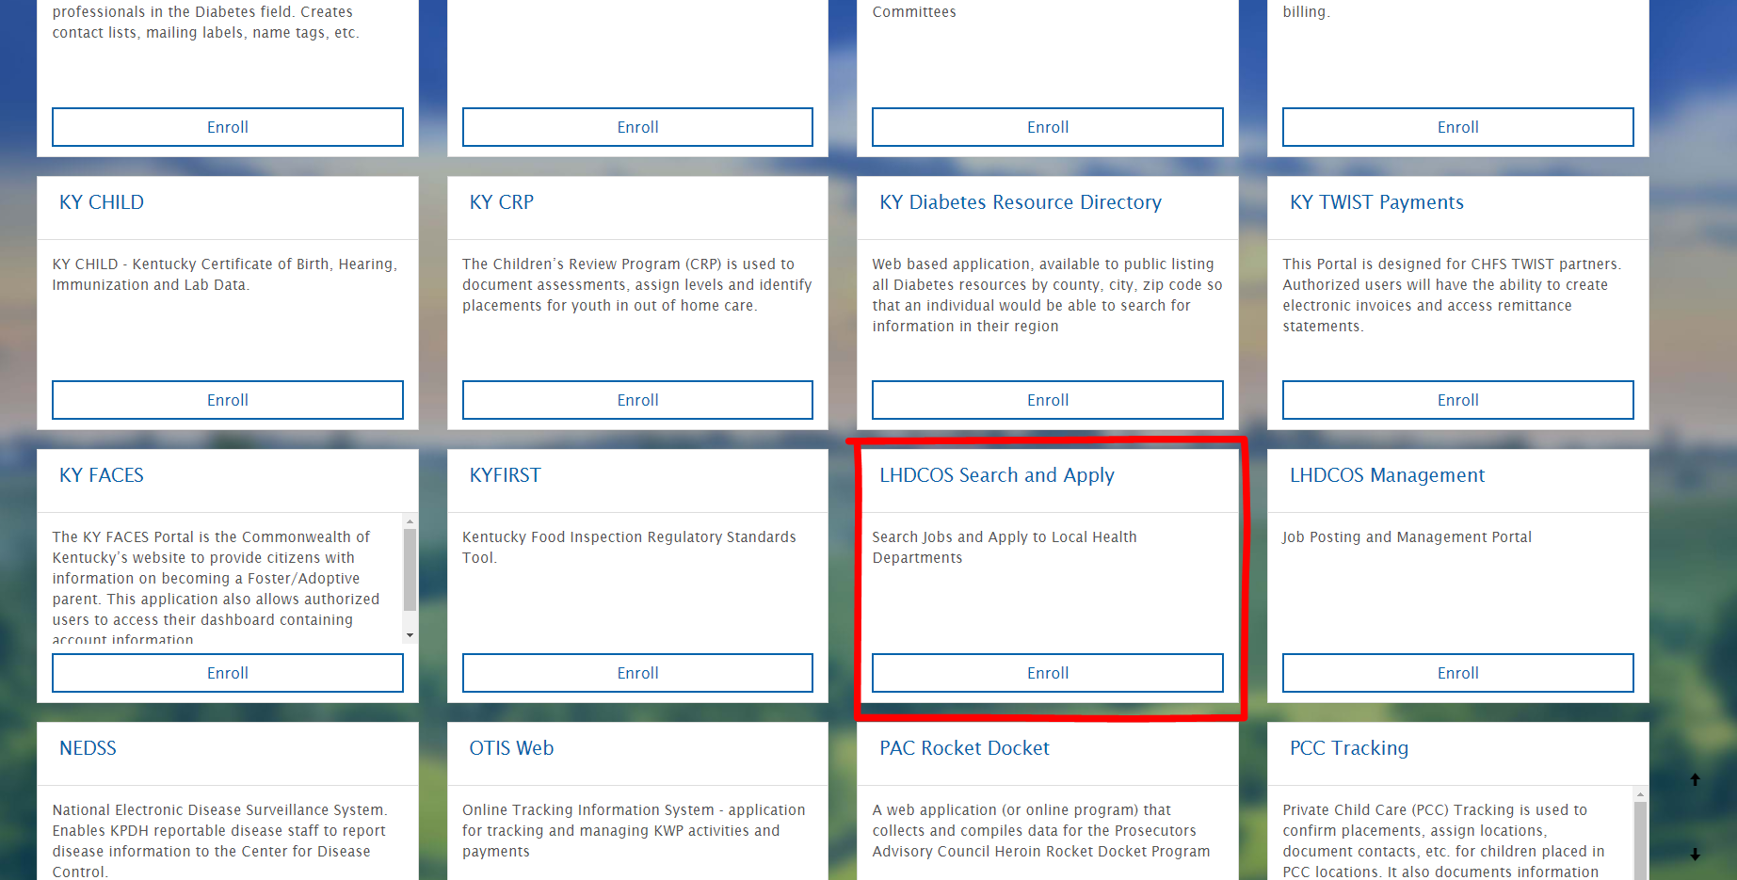
Scroll down until you see this tile.

searching and applying for jobs
The applicant will see the home page below. The options are: search for jobs or create your profile. A profile must be completed to apply to openings. A profile is what is submitted as the application. Once a profile is created, you will be able to update it. You can search for jobs before creating a profile.
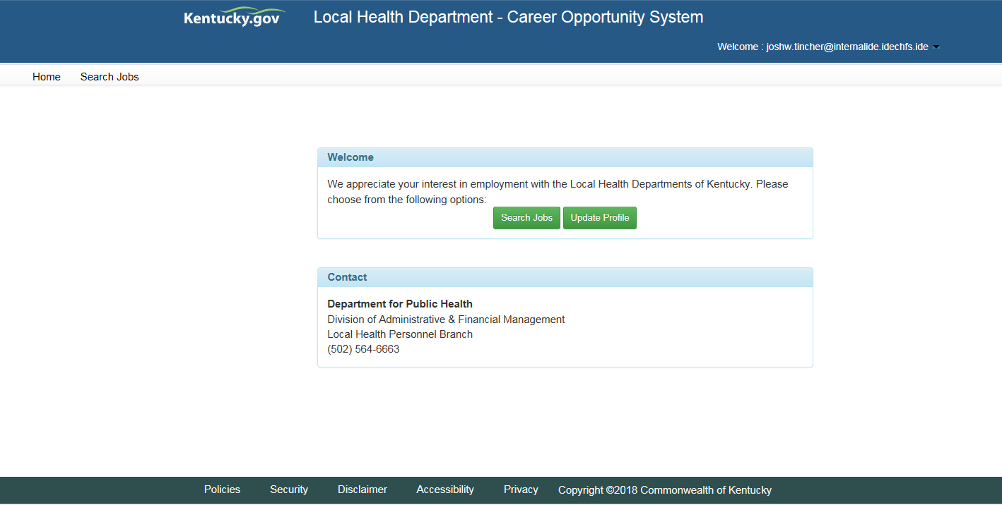

Fill out the required fields, marked with an * in the profile. Click Save and Continue to advance to the next page of the application.

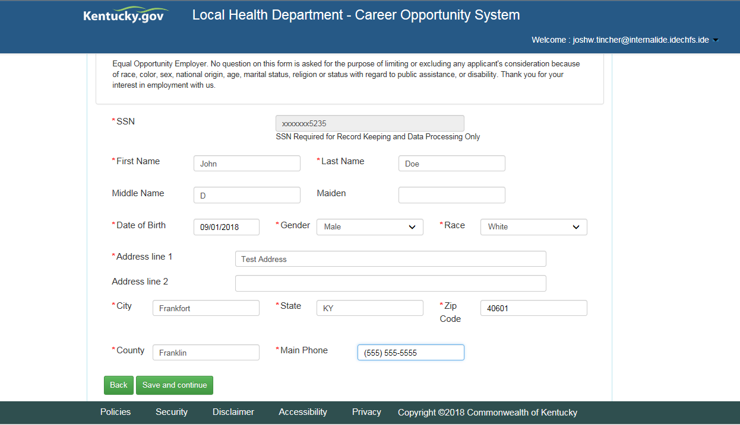
Upload Transcripts in the section below. Uploaded documents will be displayed in a grid below.

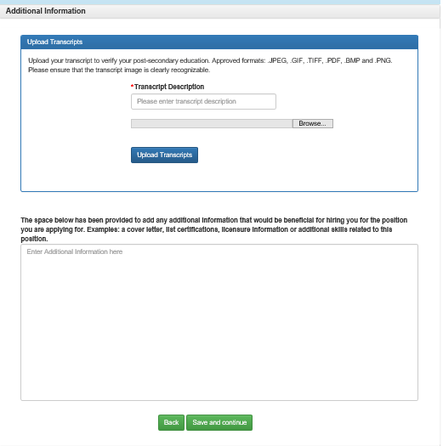

Additional information related to your education or experience that you could not provide any of the sections above may use the selection below the Transcript Upload to enter them.

Please make sure you click "Save & continue" to save all the uploaded documents, and additional information entered, if any, in the free format text box.

The application is complete when you reach the signature page. You must click Save and continue before logging off. You may update your profile at any time.
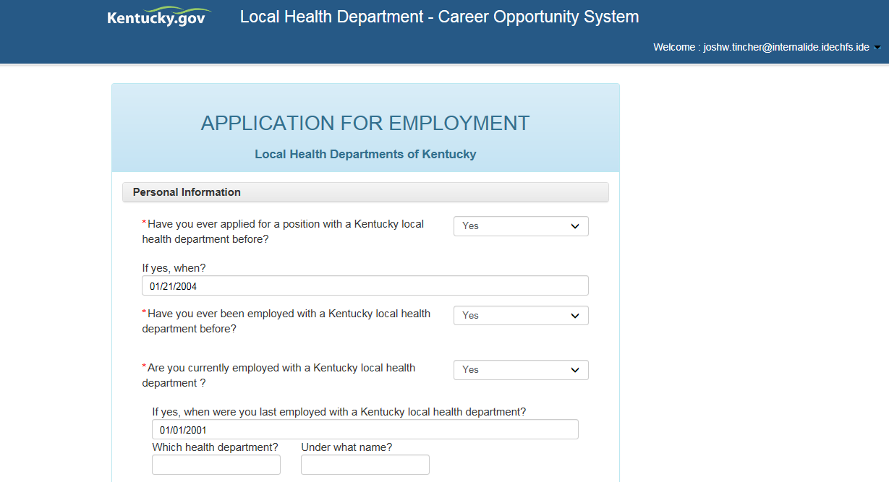

Sign the application by typing your name in the box. Enter the date and click Save and Continue.
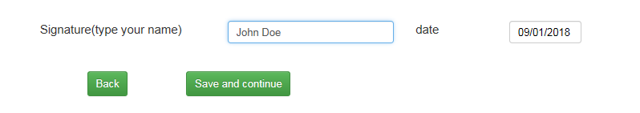

You will see the screen below. The application is completed, and you can now apply for openings. The application is good for one year from the time you signed it. After a year, you will be directed to update your application before applying for more jobs.
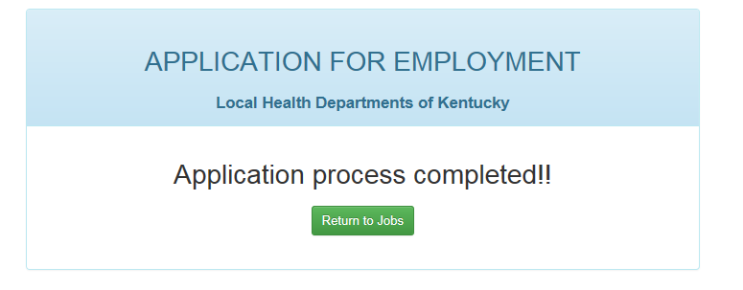

SEARCHING FOR OPENINGS
Click on the Search Jobs link on the menu bar or the button on the Home screen. You will see the screen below. Filter your search using the dropdowns and click the Search Jobs button. From the list of openings, click on the View link to see a description of the job. To apply for the job, click the Apply link.
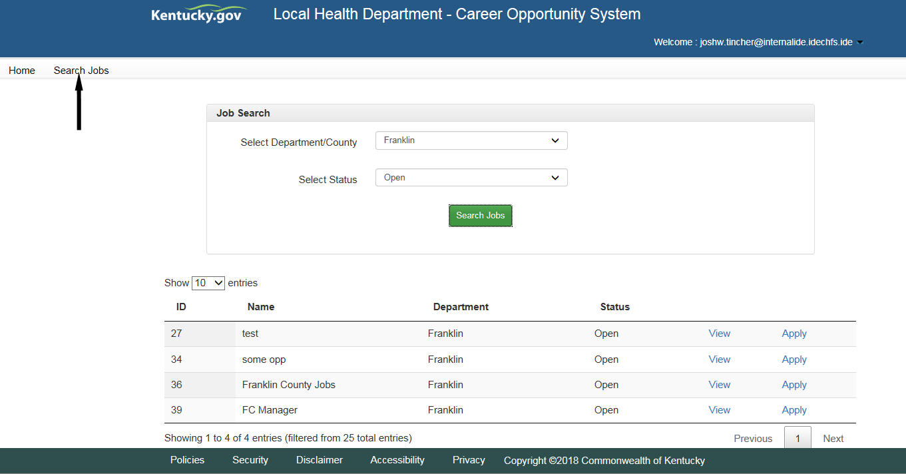
The message "Application process completed!!" will appear after you click the Apply link.
You can go back to the Job Search screen from here to continue applying for open jobs.

Applicant
The applicant must create an account on KOG. The website is https://kog.chfs.ky.gov/home/. On the home page, they will choose "create an account" and follow the instructions. Once an account is created, the applicant will search for the LHD COS tile. They will click the tile to search and apply for LHD positions.

