Press Release
Purchase District Health Department
January 19, 2021
Purchase District Health Department Confirms Additional cases of Coronavirus (COVID-19)
The Purchase District Health Department has received notification of the cases listed below:
County | Age | Sex
Ballard | 54 | F
Ballard | 50 | F
Carlisle | 70 | F
Fulton | 19 | F
Fulton | 38 | F
Fulton | 53 | F
Fulton | 34 | M
Fulton | 54 | F
Fulton | 67 | F
Fulton | 27 | F
Fulton | 10 | M
Fulton | 54 | F
Fulton | 41 | M
Fulton | 25 | M
Fulton | 38 | F
Hickman | 74 | M
Hickman | 20 | M
Hickman | 18 | F
Hickman | 74 | M
McCracken | 22 | M
McCracken | 66 | M
McCracken | 69 | F
McCracken | 5 mo | M
McCracken | 52 | F
McCracken | 67 | F
McCracken | 42 | M
McCracken | 48 | F
McCracken | 25 | M
McCracken | 58 | F
McCracken | 47 | F
McCracken | 17 | F
McCracken | 38 | M
McCracken | 46 | M
McCracken | 47 | M
McCracken | 24 | M
McCracken | 75 | F
McCracken | 15 | M
McCracken | 39 | M
McCracken | 41 | M
McCracken | 43 | F
McCracken | 67 | F
McCracken | 28 | F

 | Ballard | Carlisle | Fulton | Hickman | McCracken
TOTAL | 473 | 493 | 376 | 354 | 4759
ACTIVE | 44 | 91 | 22 | 22 | 382
HOSPITALIZED | 4 | 1 | 0 | 2 | 23
DECEASED | 5 | 3 | 10 | 11 | 85
Additional details about these individuals cannot be provided because of medical privacy laws.
The Purchase District Health Department Vaccination Plan is available at the following link: PDHD Vaccination Plan
The Purchase District Health Department understands that accurate and up to date COVID-19 data is critical. Both individuals and organizations utilize this data to make the most informed decisions to keep people safer through this pandemic. Data that the Purchase District Health Department publishes in the press release is provisional data that hasn’t yet gone through rigorous investigation and is subject to change. Due to this, not every aspect of the data will be precise, and the Purchase District Health Department doesn’t expect it to be. Therefore, corrections are written on the press release in order to provide comprehensive and transparent data. The Purchase District Health Department wants the data as accurate as possible. The Purchase District Health Department is constantly working with positive cases, contact tracers, EMS, labs, and testing facilities to ensure that the public receives the most recent data available, even if that includes changes. One case in McCracken County was found to be a duplicate. One case reported in Hickman County was found to be a Fulton County case. One case reported as Fulton County was found to be a Ballard County case.
The Purchase District Health Department offers these tips:
• Wash your hands often with soap and water, especially after going to the bathroom; before eating; and after blowing your nose, coughing, or sneezing.
• Avoid close contact with people who are sick.
• Avoid touching your eyes, nose and mouth.
• Stay home when you are sick.
• Cover your cough or sneeze with a tissue, then throw the tissue in the trash.
• Clean and disinfect frequently touched objects and surfaces using a regular household cleaning spray or wipe.
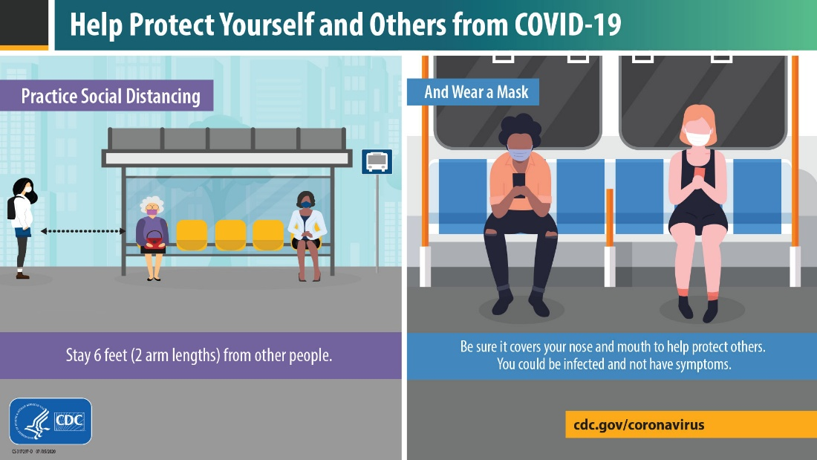
The Purchase District Health Department is working with best interests of our community with reference to statewide guidance and in consultation with KDPH to promote an efficient, standardized, sustainable system supporting all Kentuckians. By rapidly identifying and isolating new COVID-19 cases, the PDHD maintains a high-yield public health intervention to mitigate unrestrained spread of disease. All new COVID-19 cases will be provided written and/or verbal education related to exposure criteria and they will be asked to notify all family, friends, coworkers, and any others who may meet exposure criteria to self-quarantine.
This virus can be spread by respiratory droplets. Symptoms of COVID-19 may include fever, cough, loss of taste, or shortness of breath. Individuals who are experiencing symptoms should first contact their primary care medical provider.
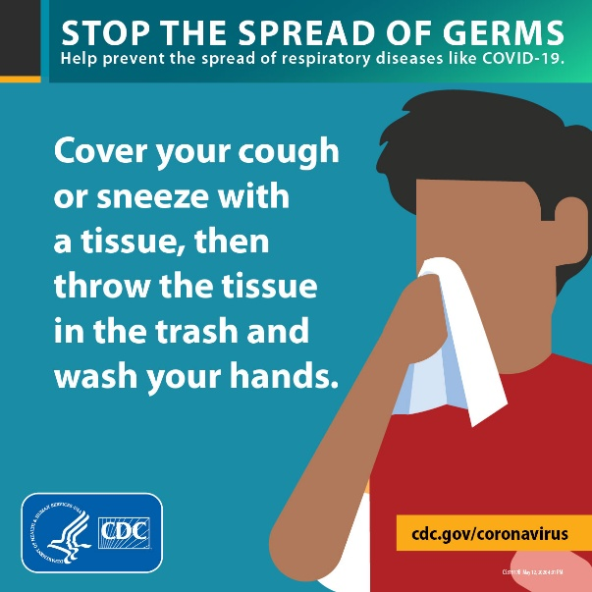
If you are worried or concerned, but otherwise healthy, please see kycovid19.ky.gov for additional information or call the Ky Covid-19 hotline at 1-800-722-5725. Call your medical provider if you develop signs or symptoms of COVID-19. Call the Purchase District Health Department at 270-444-9631 or visit our website www.purchasehealth.org for more information.
Recognizing that COVID-19-related deaths currently rank third among causes of death in Kentucky, KDPH is planning for the equitable distribution of the vaccine. Expect vaccine distribution details to change as it is an ongoing process. These details include the number of doses and allocation plan. KDPH plans to roll out the vaccine in phases. The PDHD is currently gathering information to ensure a smooth rollout of the phased plan. Vaccine is beginning to be distributed to hospitals and health departments to be administered to hospital workers and 1st responders as a part of phase 1 of the State vaccination plan. More vaccines will be available over the next few weeks and months. The PDHD will continue to provide updates about vaccine distribution when more vaccine doses become available so that the public knows what to expect. For up-to-date information on Kentucky’s COVID-19 vaccination efforts, please visit https://govstatus.egov.com/ky-covid-vaccine. CDC information regarding the COVID-19 vaccination can be found at https://www.cdc.gov/coronavirus/2019-ncov/vaccines/.
Upcoming ECT COVID Testing Schedule
For more information contact Erin Stallins at 270-709-1283
This schedule will be pending weather.

Tuesday, January 19, 2021 9:30-12:30
Fulton County Health Clinic
402 Troy Avenue, Hickman, KY

Wednesday, January 20, 2021 9:30-12:30
Fulton County Health Clinic
350 Browder Street, Fulton, KY

Thursday, January 21, 2021 9:30-12:30
Hickman County Health Clinic
370 S. Washington St., Clinton, KY

Friday, January 22, 2021 9:00-12:00
Purchase District Health Department
916 Kentucky Ave., Paducah, KY

Monday, January 25, 2021 9:30-12:30
Ballard County Health Clinic
198 Bluegrass Dr., LaCenter, KY

Tuesday, January 26, 2021 9:30-12:30
Carlisle County Health Clinic
62 John Roberts Drive, Bardwell, KY

Wednesday, Jan. 27, 2021 9:00 – 12:00
Purchase District Health Department
916 Kentucky Ave., Paducah, KY

