What is Teledentistry?

Teledentistry is the use of telecommunications technology to facilitate dental care. By electronically sharing intraoral photos, extra-oral photos, radiographs, notes, and other clinical data, teledentistry creates a variety of opportunities to expand the reach and provide a higher level of care to patients while adding convenience for both providers and the patients.

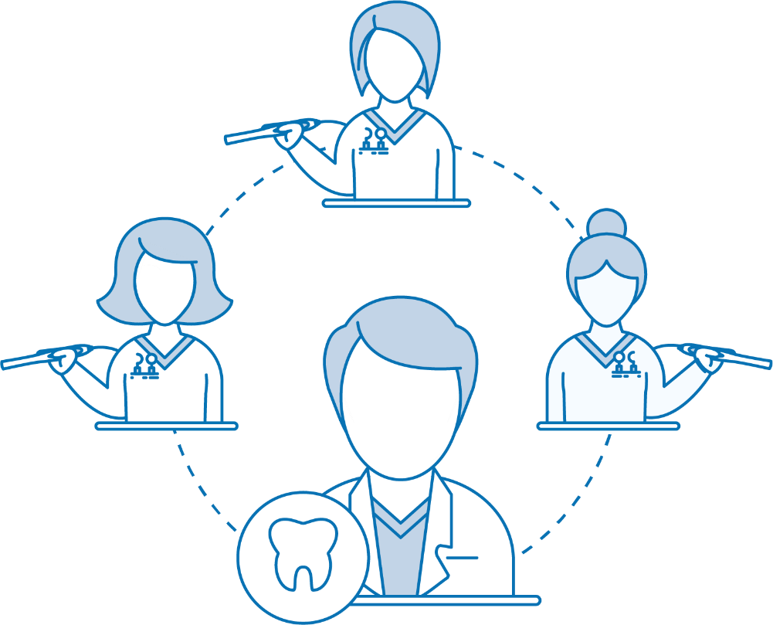

Get more out of your school visit!

PDHD staff trained with TeleDent, will be opening doorways to clinical limited oral exams for patients. Dentists will provide quality assessments, diagnoses, and treatment plans to patients in schools. This can reduce the number of visits needed for follow-up care.

